- On the admin dashboard sa PRODUCT MANAGEMENT maka pag search siya ng name ng kanyang mga display renter then mag shoshow yung mga products na display ni renter.
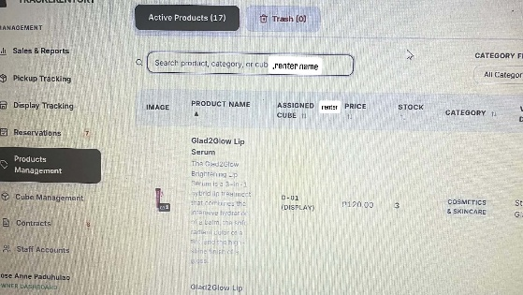
Ex. Search nya name ni marie(si display renter) then mag shoshow na mga products na inadd ni marie sa system na also naka display sa store.

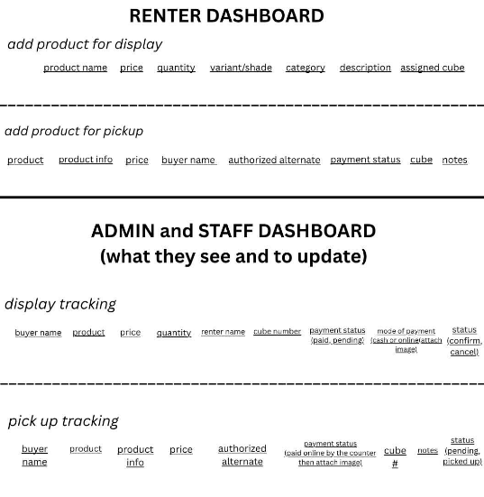
- On the admin dashboard sa RESERVATIONS gawin nlng for cube reservation only. Remove nlng yung product reservation kasi meron naman DISPLAY TRACKING which is doon makikita yung mga na reserve na products.

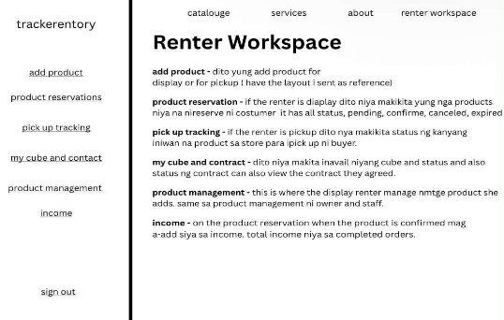
- Renter dashboard - lagyan ng side panel para didto mamili same sa interface nila ownerandstaff.

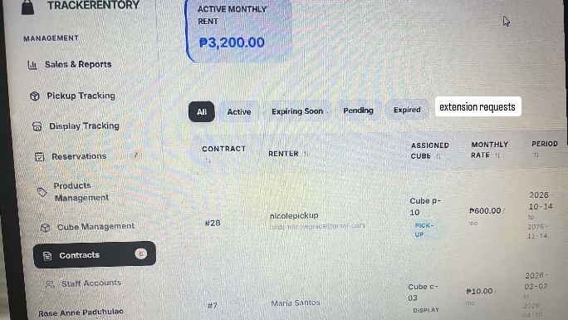
- Cube extension – only when the contract expires mag labas yung extension button sa dashboard ni renter. Then add extension request sa contracts ni owner dashboard para doon mag labas if may mag extend (approve and decline; when approve is mag direct sa create contract so mag gawa ng another)

- Interface ni renter, owner, staff

- change the “reserve for store pick up” to “reserve” only
- when done reserving the product – pop up yung message na “Your product has been reserved! Claim it before the reservation period expires.” With a button “Okay”
- on the ABOUT add PRODUCT RESERVATION “Reserve your desired product online and claim it in-store within the specified time limit.”
- About sa pick up po on how it works para mas ma understand Ninyo.
